This is a test document containing images generated by AI. Below you will find a scenic mountain landscape.

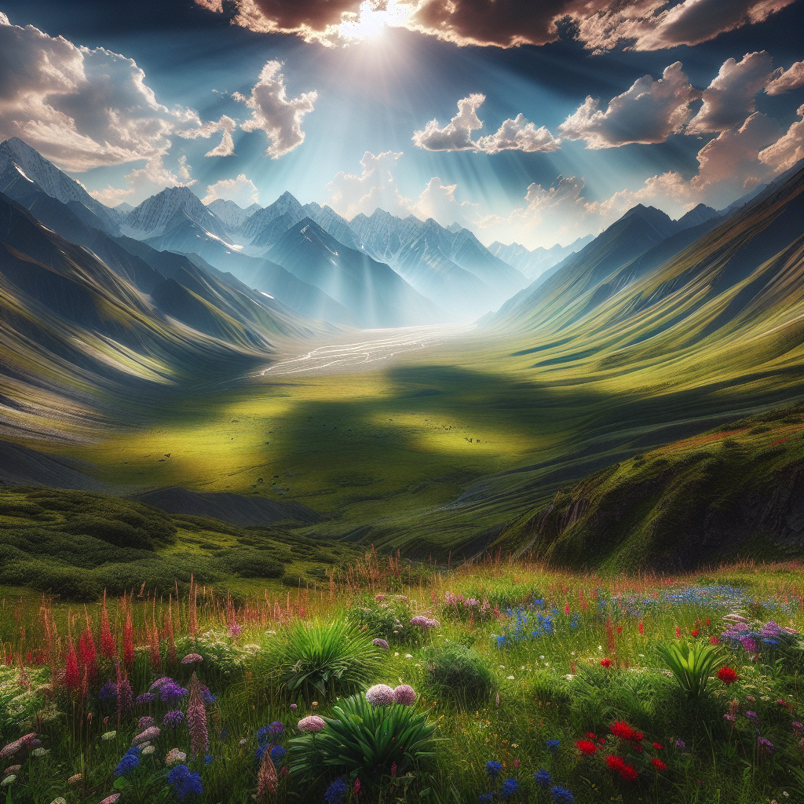

A scenic mountain landscape

In contrast, this image shows a calm beach at sunset, another serene and visually appealing landscape.



A calm beach at sunset